Your Heart Wants What It Wants:
Not A Sedentary Lifestyle

Danny Gastin

Sedentary Lifestyle:
It was 1:00 am in the morning when the door to my room burst open. “Come quick!” A voice that sounded like my sisters yelled from down the hall. I pulled on the dirty sweatshirt that I had thrown on top of my laundry basket last week and rushed out, tripping over various unopened textbooks and shoes as I closed the door behind me. It was my dad. Apparently he had woken up, rubbing his chest violently, as if desperately trying to put out a some internal fire. I had never seen my dad cry before and I think tonight would probably come to be the closest I would ever see him in tears. I wasn’t sure what was going on other than he was experiencing very bad, debilitating chest pain. My mom, gathered some things together as I paced back and forth in the kitchen. The clock ticked slower and so did my feet but before I knew it we were in the waiting room of Mercy General Hospital. The doctor came out and my mom told me to wait with my sister in the corner seats by the vending machine until she got back. I drifted off to sleep and when I awoke three hours had gone by and my mom was still nowhere to be seen. I looked over at my sleeping sister and a horrible feeling washed over me. Another two hours later my mom came out and she was crying. Makeup ran down her face and I knew. My dad had died. The silence in the car had never sounded so loud. Muffled sobs and runny noses echoed on and off when my mom finally broke the silence. Your dad died on the operating table when he went in for an emergency heart surgery after he had a heart attack. The doctors could not specifically determine the cause of the heart attack until I told them how over the years he had become very sedentary and almost completely lacked the motivation to get any physical exercise. The last time I took your father to the doctor he specifically warned him about his lifestyle choice and how so little movement throughout the day for a sustained period of time could bring about immeasurable effects on the cardiovascular system. When I got home I ran upstairs and locked myself in my room, opening my computer, typing in sedentary and heart into the search bar. I don’t know if what I found made me feel any better or just completely worse. Worldwide, “it is estimated that a sedentary lifestyle is responsible for 6% of coronary heart disease” (Joyner & Green, 2009). Further, findings relating sedentary behavior and increased risk of cardiovascular disease among adults correlated to “two hours per day of screen time and sitting time linked a 5% and 17% increased risk of cardiovascular damage” (Joyner & Green, 2009). In children and teenagars specifically, an immobile lifestyle has been seen to increase blood pressure and improve the endothelial function among young adults (Getbritainstanding, n.d.). As I continued surfing the web, finding any information I could, I read that “both light intensity and moderate-to-vigorous physical activity breaks, but not standing, might reduce inflammatory responses in adults” (Lifespanfitness, 2013). I continued reading and clicked on an article that mentioned how “pulmonary embolism is also a common cause of cardiovascular morbidity and mortality and it is typically a consequence of a deep vein thrombosis in the lower extremities”(Joyner & Green, 2009). It scared me when I read that even prolonged work and computer-related seated immobility has been found to be associated with an increased risk of venous thromboembolism (Getbritainstanding, n.d.). In a study done by Blair & Morris, he found that in the 1950s that rates of cardiovascular disease were much lower in drivers of the double-decker buses in London compared to that of the more sedentary singular level bus. “In many studies, regular vigorous exercise or occupational physical activity has been shown to reduce the risk of cardiovascular disease by one-third to one-half. More importantly, very high levels of cardiorespiratory fitness appear to reduce these risks by up to 60–70%” (Blair & Morris, 2009). I closed my laptop and tried to let all the information soak in. I stood up, fearing that I too had been sitting for too long and walked around my room, wondering out loud how my life was about to change.
There seems to be a common misconception that leading a sedentary lifestyle has inconsequential effects and that merely getting up and walking won’t make much of a difference. In a study by Tremblay et al., it is found that sedentary lifestyles are not only caused by personal attributes but very much by social influence. They tested the effects that sedentary lifestyle had on people’s physiology and health and found that in addition to substantial impacts, predicted that changing public perception to treat sedentary lifestyles as a public health issue is a challenge.
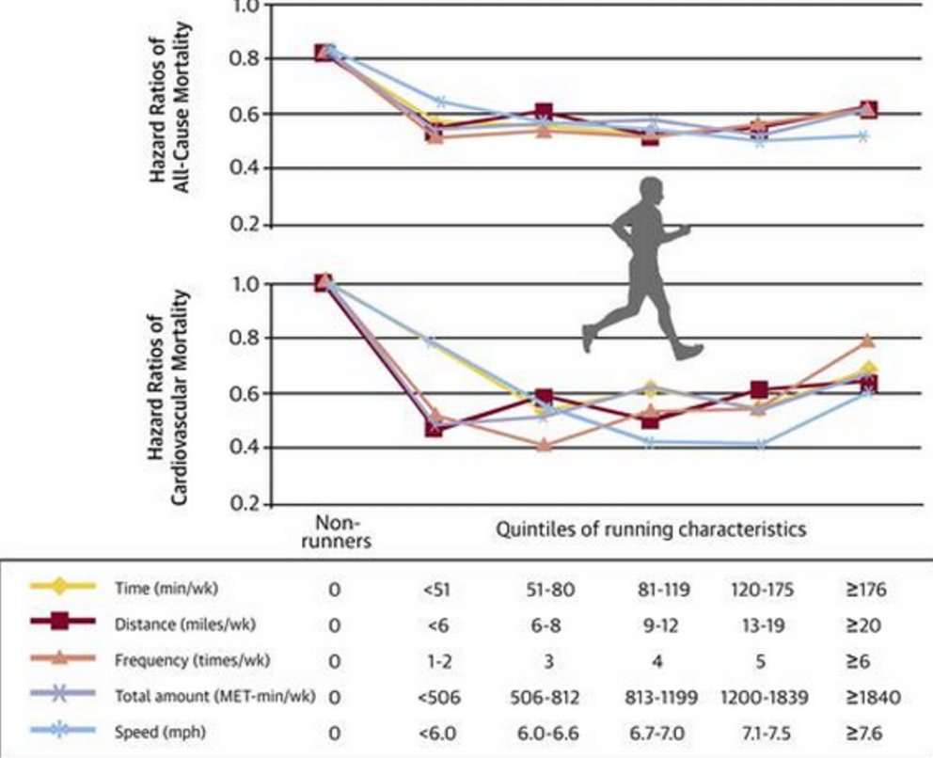
We believe this misconception is why it may be hard to convince people to avoid sedentary lifestyles. It's not only easier to sit but is doing the opposite really going to make that much of a difference? That is why we have come up with subtle less explicit influence messages that do not fully follow the traditional route of playing on people’s fear of the health risks that arises from being sedentary. These subtle messages are more so designed to subconsciously influence and make you actually like leading active lifestyles by using friends and family and an impetus. Even though our messages will inevitably still play on fear appeal a little, we believe that this different approach may be the change needed to bring to light that sedentary lifestyles are a public health concern.

Communication Concepts:
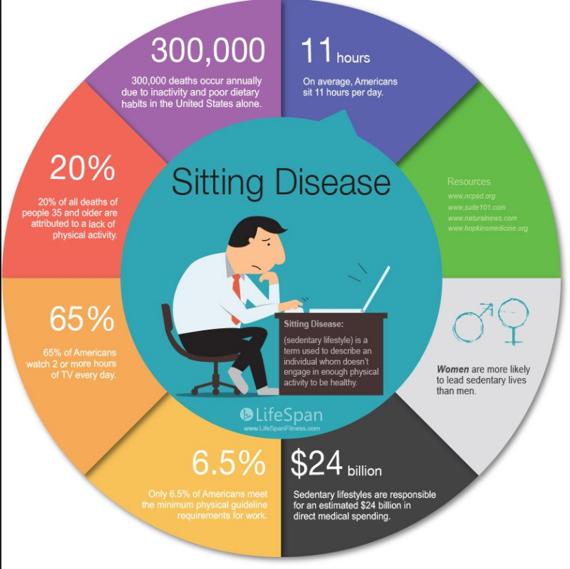
In class we discussed three theories that worked to establish a certain level of persuasion. The first method of persuasion is called the Elaboration Likelihood Theory. This theory consists of two routes: the central and the peripheral route. Each route is specific to the type of cognitive processing the audience or viewer is inclined to utilize in their understanding of the message. According to lecture and textbook material, the central route requires the viewer to place more emphasis on the physical concentration of the message content, utilizing the prerequisites of their internal motivation and actual ability to process such message content. In ads requiring this central route, the audience or viewer must be cognitively aware and willing to process the content in a much more deep manner. This route is not based on superficial signals or visual aids and does not rely on specific spokespeople or convey the message. Conversely, the peripheral route is contingent upon surface content, such as visual presentation, esthetics, number of arguments and the spokesperson representing or providing the message. This route does not require the viewer or audience to be motivated or able to process the message in a deeper form. This route is utilized primarily for individuals who may or may not have the time necessary to spend analysing the content of a given piece of information. In the narrative presented above, the information read regarding sedentary lifestyles would have been headed under the central route because, like the girl doing the research, she was motivated, willing and able to not only find the information but process and understand it as well. The severity of the girls circumstance heightens the importance of not only processing the information being read but the understanding the meanings and implications of the messages too. Today, there is so much information and news being thrown around and easily accessible to people that it is easy to get lost in translation or misunderstand the meaning of it. In terms of death’s associated from sedentary lifestyles, many people living in America today are rather cavalier in regards to the seriousness in which their lives and bodies could be impacted from living in such ways. Having messages distributed or presented through the central route is beneficial for those actively searching for that knowledge but in terms of reaching the people less inclined to do so, the message will not be headed as intensely or processed at all.
Additionally, the Mere Exposure Effect explains this phenomenon where people tend to pick up on trends and establish potentially previously unacknowledged favoritism towards things they have been in consistent contact with. This repeated exposure generates a predisposition towards the positivity of an object, subsequently heightening a positive stimuli towards the matter. Again, in regards to a sedentary lifestyle, if people are constantly being presented with the effects, consequences and warnings of living such a life, they will be more inclined to pay attention to the warnings and live a more healthy lifestyle. Furthermore, if messages stray away from the fear appeal route, doctors, marketers or whomever can utilize the notion of active lifestyles to frame that type of living in a more positive light, making it more favorable to those viewing the initial messages.
Lastly, the concept of social proof. Under this notion, individuals look towards the actions of others in regards to their accuracy and social acceptability. Social proof is a good marketing ploy for consumers who are unsure of a product's market consumption, allowing for a ground comparison and touch points. Individuals are more inclined to view their actions and behavior as being correct to the extent that they see others people acting in accordance. As noted above, if health professionals utilize content in their messages that illustrate the positive effects of living a healthy lifestyle, more people viewing that message will be subsequently inclined to follow suit. No one wants to be the only person acting out of character or social order so the more people engage in a certain or specific activity, the more it will be accepted as the norm.
Friends Don’t Let Friends Sit Around:
For our first message, we decided to use a billboard visual to appeal to our demographic of young adults aged 18-29. We decided to match this message with our youngest target demographic simply because they are more likely to encounter it in their daily routines. Although everyone drives, young adults in theory should drive more than other demographics.
One reason is that when people, specifically young adults, first get their license they are eager to show it off and explore their newfound freedom. Another reason is that young people seem to take more day and road trips than older adults because of their lack of responsibilities such as children.
For this message, we plan to take advantage of the peripheral route of the Elaboration Likelihood Model. First developed by John Cacioppo and Richard E. Petty in the mid-1980’s this dual processing model argues that people process stimuli through two different ways or routes. The central route posits that the audience will be influenced by the strength of the argument presented in a message. Conversely, the peripheral route argues that the audience will be influenced by the superficial cues of the message (Schuldt, 2016).
One important claim in this model is that attitude change is more likely to occur when a message is processed through the central route. Although our main goal is to ultimately get people to think positively about an active lifestyle and actually get moving, we realize that accomplishing that in one message is nearly impossible. Instead we want to play on the peripheral routes ability to subtly influence people. By merely observing this message while driving, we hope that our target demographic will subconsciously internalize this message so that they slowly but surely begin to think negatively about leading a sedentary lifestyle.
To ensure that this message can effectively influence our audience subconsciously, we have added two important factors to our billboard message. The first element is the text in the message. Our billboard will say “Friends don’t let friends sit around”. We will present these words in a bold, black font to stand out against our white background. These words will not only jump out at our intended demographic, but also influence them through the idea of social proof. By saying that friends don’t let friends sit around, we are setting the precedent that all friends are encouraging their friends to be active; therefore, if you are not encouraging your friends to be active you are going against the norm, combining both the peripheral route nature of the delivery of the message with the social proof nature of the content of the message.
The final aspect of our message that will increase its influence is the image we put on the billboard. Along with “Friends don’t let friends sit around” we will add a picture of Uncle Sam, the famous political cartoon utilized during World War II. We expect this image to add to the influence of our message because it conveys authority, which is one of Cialdini’s Six Principles of Persuasion. Uncle Sam’s appearance in general adds a sense of authority and wisdom, but the real subtle influence comes from the strong social and political sentiments associated with him.
Yesterday You Said Tomorrow:
Our second message involved the use of graphic-designed refrigerator magnets, used in order to reach our target audience of 49 year old parents. We chose these magnets because we felt, in understanding our target audience that they offered a strong opportunity to implement the Mere Exposure Effect, one of the theory that we chose to operationalize in changing people’s sedentary lifestyle habits. Mere exposure is described as the “repeated exposure to a stimulus (e.g., object, person) leads to greater liking for that stimulus” (Schuldt, 2016). We chose mere exposure because it is a proven, yet simplistic form of social influence that would be feasible to create a message for; it encourages an active lifestyle and discourages a sedentary one. Additionally, our message surrounding the main concept of the mere exposure effect is supplemented by the theory of cognitive dissonance and its potential negative effects. This message comes in the form of our refrigerator magnets.
We chose to target 49 year old parents because we wanted to pinpoint a specific target age for the sake of our message having a clear focus. With that in mind, the message can be generalized and utilized by anyone with similar sedentary habits because they are not genetic. The associations between bodily disease and health are associated with lifestyle behaviors and thus, our message can be extrapolated to anyone with sedentary habits (Marck et al., 2016).
Knowing who exactly our target audience was, we needed to think of a way to integrate a message into their daily lives that would be subtle, but would still be seen repeatedly each day. According to CBS, 63% of American households with children under-18 cook dinner at home at least 5 nights out of the week. This means that parents are constantly going in and out of their refrigerators when crafting meals. Knowing this, we chose refrigerator magnets because they are front and center on the door and will be seen each time the refrigerator is opened and closed.
The design of the magnets was strategic and purposeful. They are arched on the top by the message “Yesterday You Said Tomorrow” and a visual of an individual being active (there are male and female magnet versions), specifically to further play off of the effects of mere exposure. Our goal in creating repeated exposure around this slogan is for our targeted group to read it and reflect in such a manner;
Wow, I remember seeing this yesterday and thinking to myself that I would go to the gym today, but I never did. Yesterday I said I’d be active today, but I was obviously wasn’t so I am going to make a point to ensure that I am active tonight and not put it off any longer.
With this thought process combined with repeated exposure, we intend to increase individual’s liking of being active today and not putting off activity until tomorrow. It plays off of the theory of cognitive dissonance in which individuals have two inconsistent cognitions creating self-dissonance, an uncomfortable situation that we tend to address with an attitude or behavioral change (Schuldt, 2016). People may have the attitude that being active is important, but not back that up with their behavior. Repeated exposure to the refrigerator magnet will remind them of this inconsistency and create dissonance which viewers will address by changing the behavior (due to our specific message) of putting off activity until tomorrow to being active today.
In addition, the setting of the kitchen lends itself to familial situations. When these adults see this message, family will also be in their head at the same time. With regards to valence and which way mere exposure may push an adult’s beliefs and attitudes, we believe that since the adults are next to their children or making food for their families, the positive valence they receive from the message towards leading an active lifestyle would be amplified because they are thinking how important their health is in regards to their families. Negative valence in this situation is unlikely because since they are concerned with their family, it would create a disconnect between and dissonance in thinking badly of a healthy lifestyle and how important their health is to their families.
All in all, the overall goal of this persuasive message is to utilize the concept of mere exposure in order to build implicit attitudes and change ingrained behavioral patterns towards living a more active lifestyle. The higher visual frequency and contact with the message will make the viewer feel more positively towards being active and in doing so, change sedentary lifestyle behaviors and hopefully prevent the onset of heart disease.
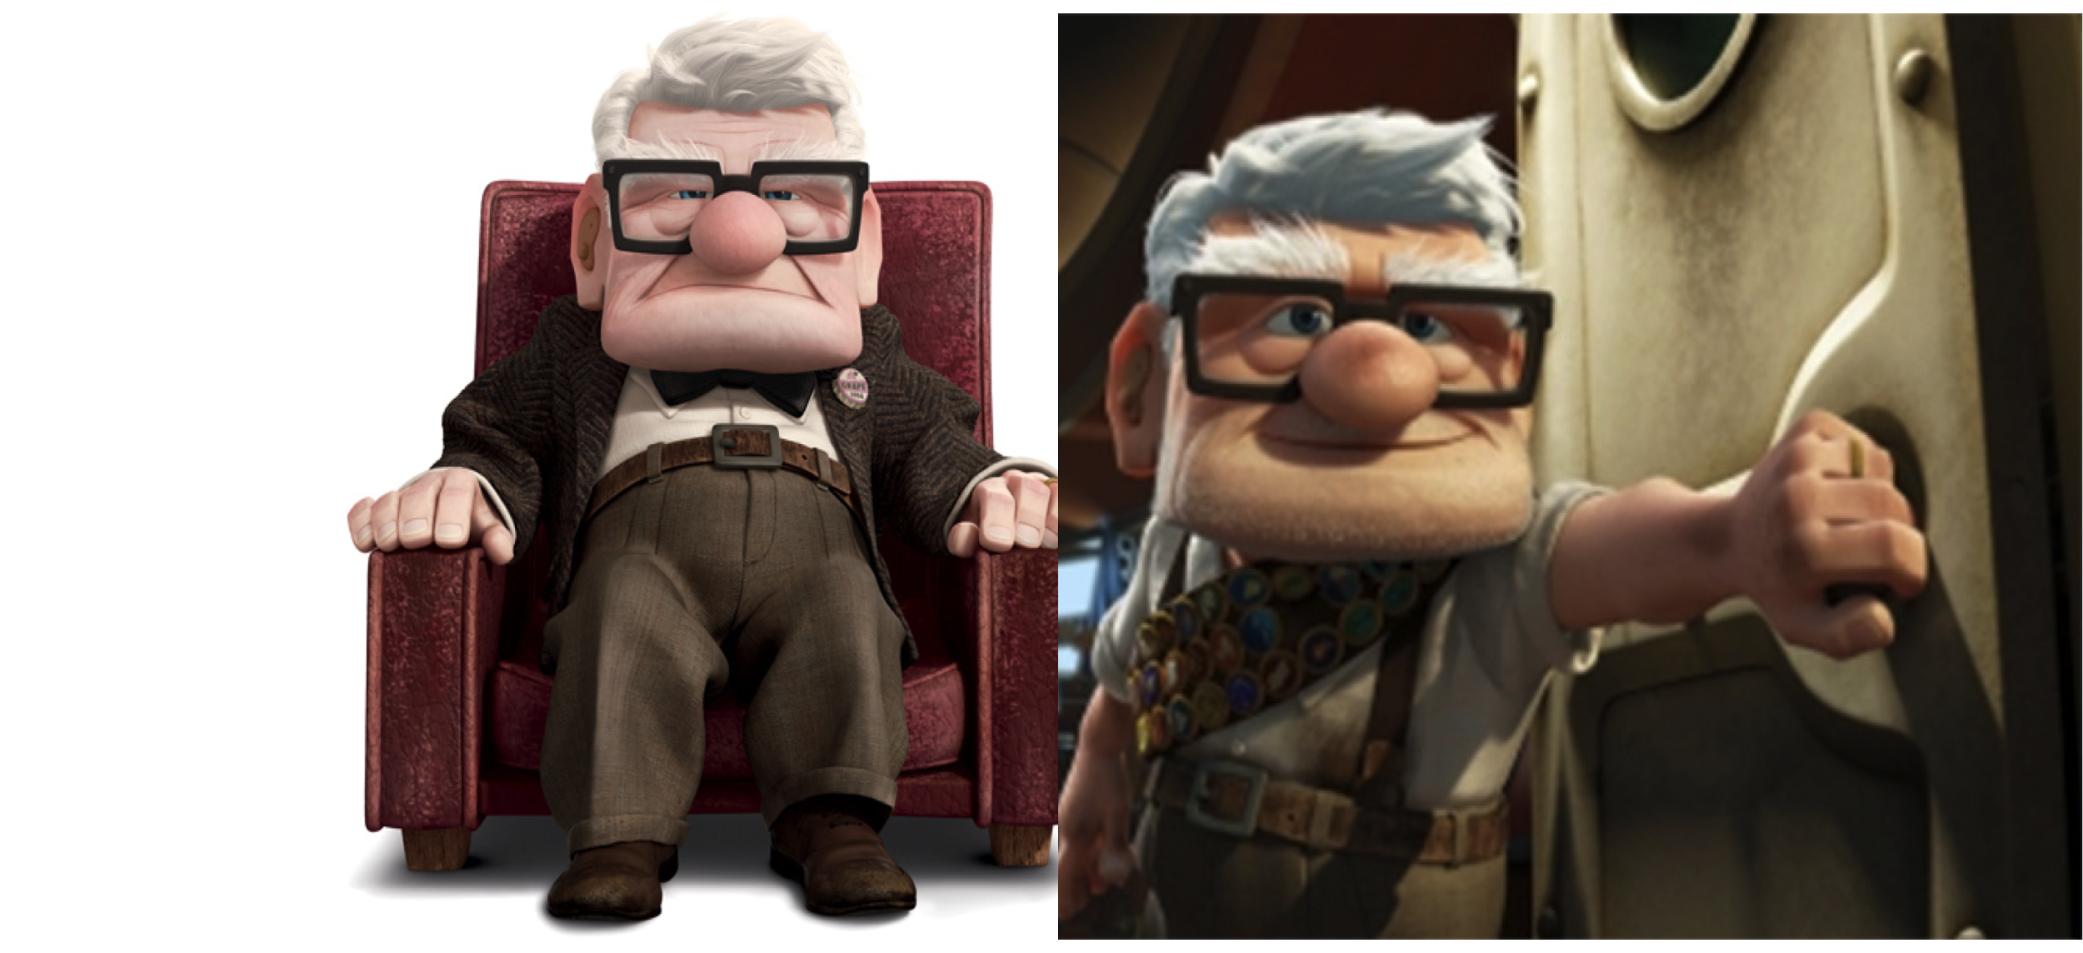
No Excuses, Just Like Them, You Can Do This Too:

Social influence occurs at all ages, from a 29 year old who is in the workforce, to a 69 year old who is retired and has more time for leisurely activities. Because those in the 69 year old age range are more likely to have the time to spend sitting down watching TV without having to worry about responsibilities that they might have had 40 years ago, we chose to target this group for our PSA message. Our PSA message will utilize Cialdini’s theory of Social Proof. Simply put, Social Proof says, “we view a behavior as correct in a given situation to the degree that we see others performing it” (Cialdini, 2009). So to utilize this concept, our TV commercial will use adults of both sexes (male and female) that are labeled as older adults in the 69 age group, and partaking in physical activities, such as running, lifting weights, swimming, and yoga. The concept comes into effect upon the viewer (the retired individuals) viewing the similar aged individuals in the ads, participating in the activities. By viewing these ads, the viewer will see that this behavior is the correct behavior due to the popularity of others engaging in it, and that living a sedentary lifestyle is not the way to live. And by viewing this ad with people like them in it , the viewers are provided with “a convenient shortcut for determining the way to behave” (Cialdini, 2009). This convenient shortcut provides the viewers a lifestyle that is worth mirroring, and worth maintaining due to others like them engaging in it on a daily basis. Ultimately, after seeing this behavior by those their age, our goal of the message is to change the target audience and their behaviors towards living and maintaining active lifestyles.
Proposed Evaluation:
As an proposed message intervention evaluation, we will be testing the mere exposure effect utilized in our fridge magnet message targeted towards older adults around the age of 49. This experiment involves older adults participating in group activities. Even though it we would not be measuring the effects of messages on actual fridge magnets, we believe that the results of such a mere exposure experiment will effectively represent the effects being exposed to messages on fridge magnets, if not amplified due to the familial environmental factors our messaged includes.
In this experiment we recruit adults and split them into two groups. The first are those who would not be screened and would simply participate in the planned group activities. This is the control. The second group will be those who have to fill out a survey before the activities. These surveys would include benign and straightforward questions asking the participants about their feelings towards group activities such as “do you enjoy group activities?” or “are you usually exposed to group activities?” These surveys, however, will also expose participants to a brief phrase about specific physical actions accompanied by a benefit of that action. For the purpose of our message, we will be most concerned about exposing participants to a phrase that applauds getting up and moving around. These phrases will be disguised within questions so that participants are not alerted to the nature of the experiment. An example would be a phrase like “studies show that being active instead of sedentary not only boosts your health but makes you more likeable among others” that is followed by a question such as “rate on the following scale how much you usually like to move around during a group setting.” Following this survey, we have participants, both those who took the survey and those who didn’t then participate in a few group activities. In these groups, we will measure whether or not participants who saw the aforementioned phrases in the survey practice the encouraged physical actions immediately after mere exposure and to what extent. This is the dependent variable. The activities should be those that are neutral towards physical action, meaning those that do not necessitate movement but also does not discourage it. The room in which the activities take place in will have enough chairs for everyone so that people have the choice to sit. An example of an activity would be having a group figure out a puzzle on a sheet of paper. Participants could very well figure out the puzzle by staying in the seats or one could get up and move around to either better communicate or to get energy flowing in the room.
We can increase the scope of this experiment by including not only phrases that encourage moving around, but also other physical actions like shaking hands or crossing arms to get a more complete and encompassing grasp on the effects that mere exposure has on adults their actions. However, each participant will only be exposed to one phrase that recommends one action. In our message, we only expose viewers to one direct message about one proposed physical action. The experiment should reflect that and exposing participants to more than one action may create for an unaccounted for interweaving of mere exposure effects. We do not have to worry about other inconsequential parts of the survey creating a mere exposure effect as the special phrase we include will be the only explicit phrase that directly promotes a specific physical action. We can also increase breadth of the study by screening participants and controlling for some additional variables. One relevant variable that could be controlled for is whether or not the participant has children. By controlling for this variables, we may be able to identify whether or not people with children are more affected when exposed to a potential risk to their health.
For the base experiment, we predict that mere exposure to these explicit phrases will result an increase in immediate replication of the encouraged action compared to the control participants who saw no such phrase. In addition, if we were to expand the experiment to screen for whether or not participants have children, we predict that parents are more likely replicate the exposed action in their phrase if the phrase mentions the health related benefits or risks. This is because parents might be more likely to worry about their own long-term well-being since they have a responsibility to take care of other people as well.
Conclusion:
A sedentary lifestyle does not seem detrimental to many. The opposite it true with the cardiovascular risks attached to such a lifestyle. In combatting a widespread misconception, rather than attacking people’s beliefs directly, it may be more effective to try to changes beliefs and attitudes indirectly and by linking it to other factors. We chose these effects, because their ability to influence is not as explicit but the strength of their influence is still strong. The peripheral route combined with social proof with our billboard message provides a subtle delivery system with that has a lasting impact with its content. Our fridge magnets sets a constant reminder for people to get active with its mere exposure. Combined with the familial setting where fridge magnets are located, people are more motivated to be influenced by the message. With our PSA advertisement, we use the TV medium as older people are not only more likely to watch TV but TV consequently appeals to a sedentary lifestyle. By using social proof in an advertisement, we reach our target audience easily and more effectively.
I do not want others to experience what my father and my family had gone through. Getting up and walking around may seem very inconsequential, when in fact it may save lives. With our messages, we are not looking to deconstruct the misconception that a sedentary lifestyle is not substantially detrimental. We, however, want to push the our target audiences towards slowly becoming more active by not only reminding them that an active lifestyle is beneficial to their physical health but also to how it may consequently benefit those close to them or help one’s image of oneself. By combining all these factors, we think a substantial enough impact can be made within individuals to switch from a cardiovascularly risky sedentary lifestyle to a healthy and valuable active lifestyle.

References
Alfano, S. (2005). How And Where America Eats .CBS News. Retrieved from
http://www.cbsnews.com/news/how-and-where-america-eats/
Marck, C. H., Neate, S. L., Taylor, K. L., Weiland, T. J., & Jelinek, G. A. (2016). Prevalence of
Comorbidities, Overweight and Obesity in an International Sample of People with Multiple
Sclerosis and Associations with Modifiable Lifestyle Factors. Plos ONE, 11(2), 1-14.
doi:10.1371/journal.pone.014857
Cialdini, R. B. (2009). Social proof: Truths are us. In Influence: Science and Practice (5th ed., pp. 97-99). Boston, MA: Pearson Education.
Schuldt, J. (2016). Comm 2760. Attitude theory #1 [PowerPoint].
Retrieved from Cornell University Persuasion and Social Influence Blackboard:
https://blackboard.cornell.edu
Schuldt, J. (2016). Comm 2760. Attitude theory #2 [PowerPoint].
Retrieved from Cornell University Persuasion and Social Influence Blackboard:
https://blackboard.cornell.edu
Schuldt, Jonathon P. (2016). Audience characteristics and ELM.. [PowerPoint Slides].
Tremblay, M. S., Colley, R. C., Saunders, T. J., Healy, G. N., & Owen, N. (2010). Physiological and health implications of a sedentary lifestyle. Appl. Physiol. Nutr. Metab. Applied Physiology, Nutrition, and Metabolism, 35(6), 725-740. doi:10.1139/h10-079
Health Risks of a Sedentary Lifestyle. (2013, April 13). Retrieved May 05, 2016, from http://www.lifespanfitness.com/workplace/resources/articles/health-risks-of-a-sedentary-lifestyle
Top 10 Risks, (n.d.). Retrieved May 01, 2016, from
http://www.getbritainstanding.org/health-risks.php
Joyner, M. J., & Green, D. J. (2009). Exercise protects the cardiovascular system: Effects beyond traditional risk factors. The Journal of Physiology, 587(23), 5551-5558. doi:10.1113/jphysiol.2009.179432
Blair, S. N., & Morris, J. N. (2009). Healthy Hearts—and the Universal Benefits of Being Physically Active: Physical Activity and Health. Annals of Epidemiology, 19(4), 253-256. doi:10.1016/j.annepidem.2009.01.019

